An abstract

Introduction

The classification is a process describing a machine which is able to identify datums from a given set.

This report will present the study of classification on classifiying 6 different classes of binary images. The techniques behind this idea is that for a class of data they will share some common features, the machine will analysis theses features and trying to match these features with the unidentified datum, once the datum is matched then is classified. The study of such common features is known as machine learning.

There are two ways for machine learning, one is supervised and another is unsupervised. This report will discuss both types of machine learning by applying these into classification problems.

Supervised Learning

The supervised learning is a human-intervention process, the machine will trained with labelled data. The data should represent the distinguishable feature of images. To transfer this idea into practice, I use the chain code to accomplish this. The chain code will trace over the boundary of image shape, and every step, it will record the dirction of its movement as a series of coordinates. The chain code translates the images into numbers and these valuable numbers socalled features describe the shape of image which is how machine read images.

Through this way, we can obtain all feature datas and each feature data can be considered as a point in speace. Ideally, the distribution

As statistical inference, there are many approaches, In this specific classification problem, I adopt Gaussian Model:

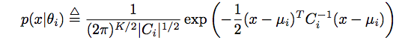

Main body what have done

Result section

Summary conclusion

bibliography